**Project Title**

Web-Based Recruitment System

**Description**

This project is aimed at developing a web-based and central Recruitment Process System for a company. Features of this system will be creating vacancies, storing Applicants data, Interview process initiation, Scheduling Interviews, Storing Interview results for the applicant and Hiring of the applicant. ROLE: HR, Responsibilities: Creating, Removing and Managing vacancies. Shortlisting and searching applicants. Conducting and Scheduling interviews. Handling accounts. Frameworks: Spring, Hibernate.

*Figure1*

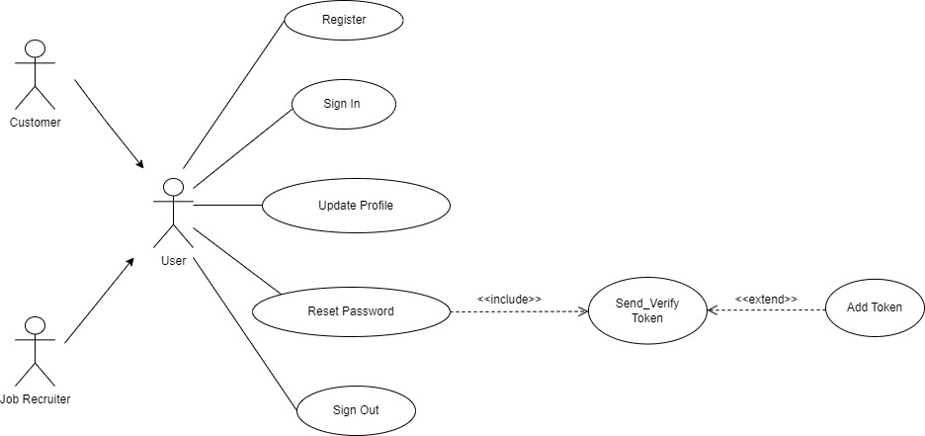

*Figure2*

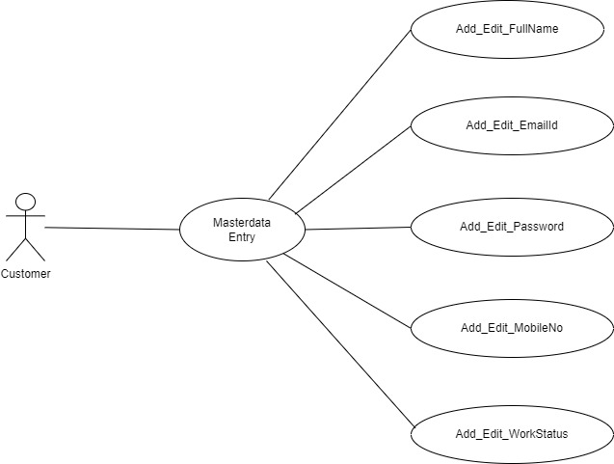

*Figure3*

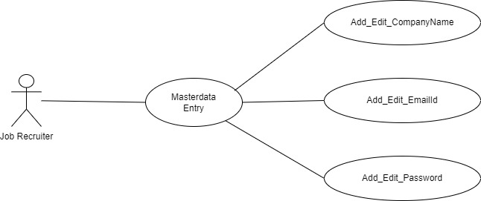

*Figure4*

